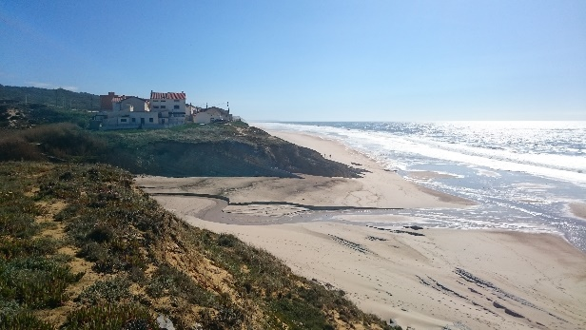
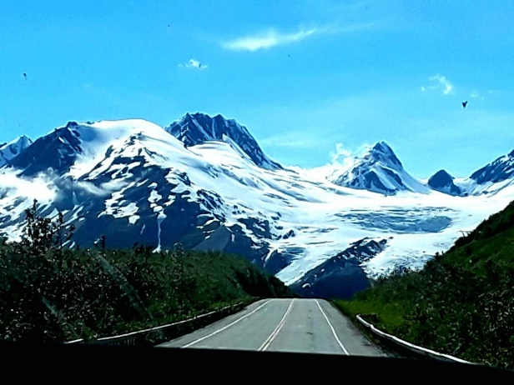

The Word of God is…
- Isaiah 40:8 “The grass withers and the flowers fade, but the Word of God stands forever.”

My challenge is…

God’s Redemptive Story
Cross of Christ
4 Gospel stories
Colossians 1:15-16
Philippians 2:6-11
Romans 5:8
1 Peter 3:18-22
1 Timothy 3:15-16
John 1:1-18

Creation
Genesis 1 & 2
Psalm 19
Genesis 1:27

Consummation
New Creation
1 Thessalonians 4:13-5:11
1 Peter 5:10-11
Revelation 21 & 22

Church
1 Corinthians 12:27
Matthew 16:18
Acts 2:42-47
1 Corinthians 1 - 15
2 Corinthians 5

Covenant
Genesis 3:15
Genesis 12:1-5
Hebrews 11:8

Consolation
(Messianic promises)
Isaiah 9
Isaiah 53
Luke 2:1-21
Luke 2:22-39

Commandments
Deuteronomy 4
Deuteronomy 6:4
Matthew 22:37-40
Confusion
Habakkuk 3:16-19
Proverbs 3:5-6
Jeremiah 20
Job
John 14:1-6

Corruption
Genesis 3
Genesis 4
Genesis 11
Romans 1:18-32
Romans 3:23

Concecration
Philippians 1:27
Ephesians 4:1
Ephesians 4:10-23
Hebrews 12:1-2
Acts 13:36
Revelation 2-3

