Can there be any hope?

November 30, 2025
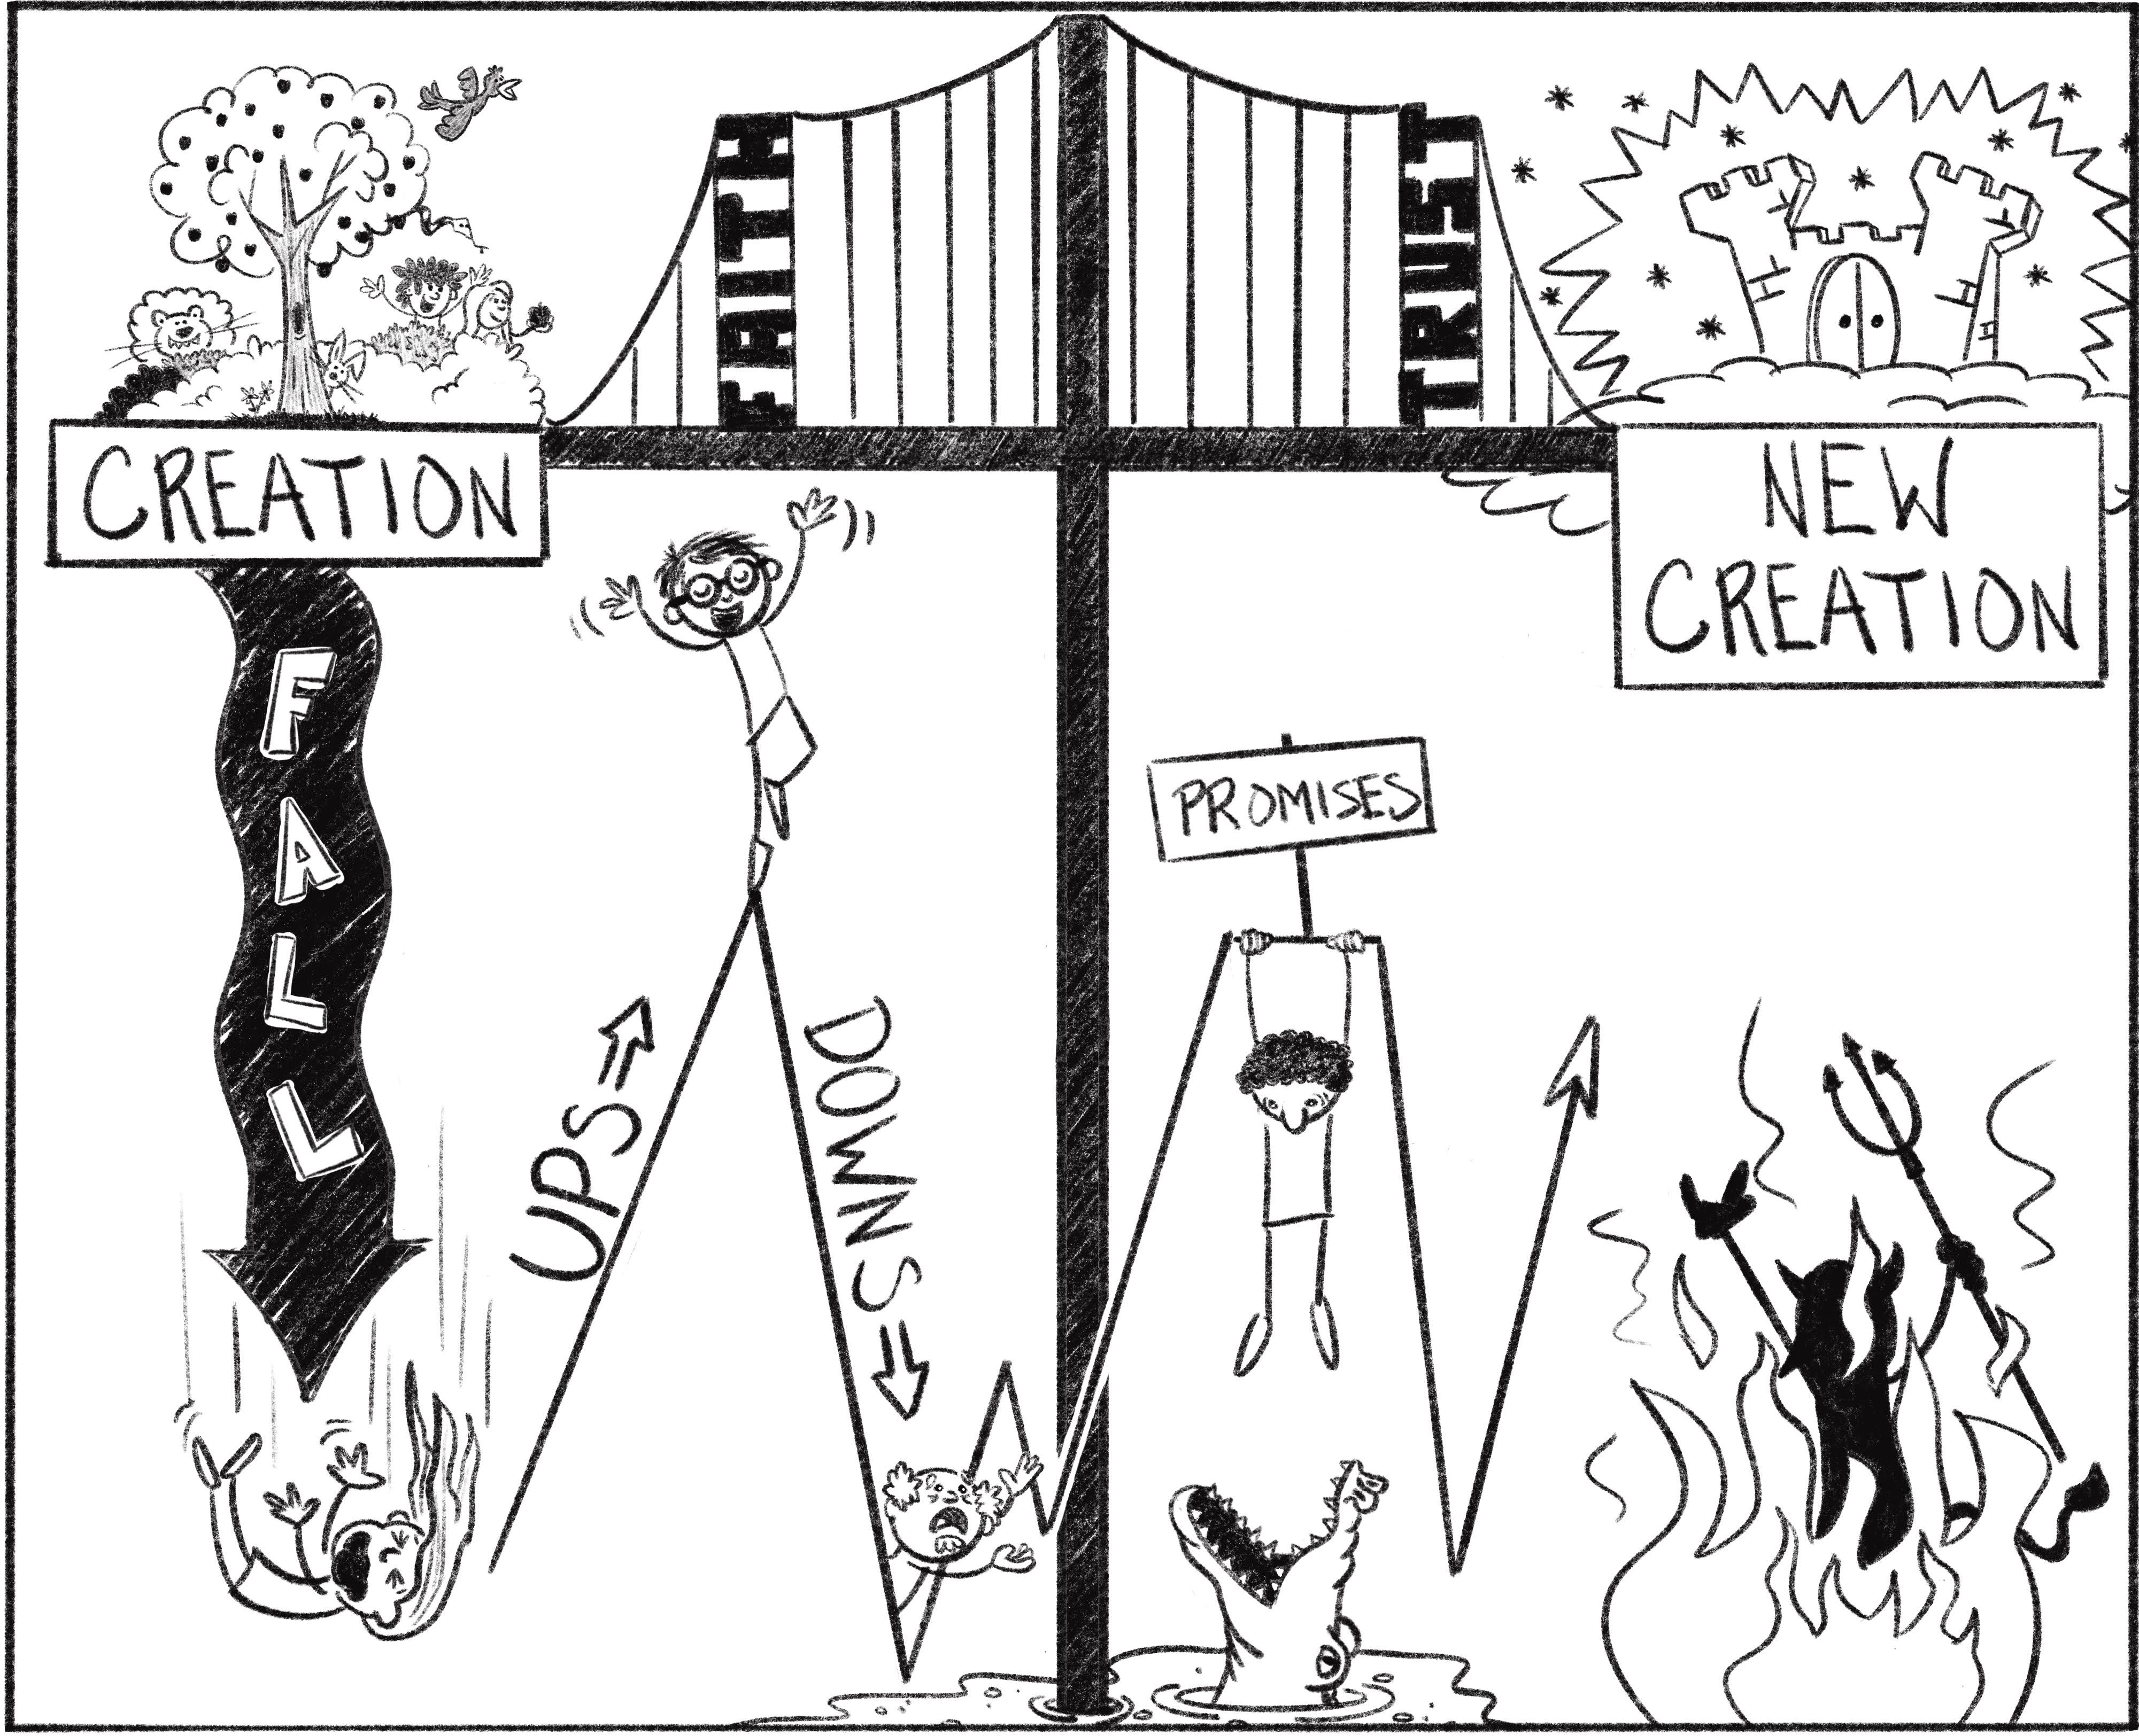
What was Creation originally like?
- Genesis 1 & 2
What is God like?
What Happened to us at the Fall?
- Genesis 3:1-13
What was and is now the result now of the Fall?
- Genesis 3:23-24

- Isaiah 8:19-22
2 Statements that are both true:
- I am born with _________________________________
- I am ________________________________ on my own
Is there any hope? ____________!!! but only in the __________________ – the _____________________
- Genesis 3:14-15
  - Isaiah 9:1-2; 6-7
    - Matthew 1:22-25
Digging Deeper: For group discussion and personal reflection
- Do any of you in the group have an ‘advent calendar’ in your home? If so, how do you use it or have you used it in the past?

- Today is the first Sunday of what is traditionally called the “Advent Season.” Have you ever been part of an Advent season at Church? What does Advent season mean?

- Read carefully the heavy passage in Isaiah 8:19 – 9:7.

- Even though Christmas is a ‘joyful’ and beautiful season of the year, why does the Bible paint the ‘waiting period’ of the arrival of the Messiah with such dark and heavy

- From the drawing on the other side of this document, where in that drawing would you place the Christmas story, and why?

- In the sermon there were two statements that on the surface look to be contrary, and yet they are both true. How are they both true?

- As you finish, read a portion of the Christmas story found in Matthew 1:18-25

- What is the power behind the term… “Emmanuel – God with us”?

- Is there an expectation and preparation in your life for the Messiah’s 2nd coming? (more to come on this as we move into the spring)

Announcements:
November 23-December 14: TLE Giving Tree
November 30: Advent Begins
November 30: Prayer Walking
December 1: Women’s Christmas Wreath Making Party
December 3: Men’s Christmas Dinner
December 6: Elders Meeting
December 7: Christmas Fest

